PrintFriendly.com: Print web pages, create PDFs | 15-03-10 10:31 AM

DIY Mammogram/MRI…
grovecanada.ca /diy-mammogram/

You need a Mac Computer with iPhoto & a Digital camera for this tutorial(I used an 8 megapixel point & shoot)…
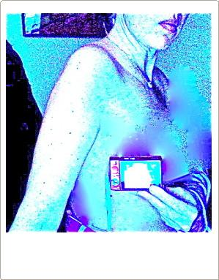
Take a picture of your breast where the lump is, close-up, in good light, with Flash On, & set to MACRO…It may take a few tries to get the whole area into the picture…Hold camera about 2-3 inches away from side of breast…(I have cropped the nipple out of this picture for modesty)…

Upload your pictures to your Mac iPhoto program, pick the best one, & Click ENHANCE…

In EFFECTS, BOOST your picture as much as possible…(For me this is 9 times)…

In ADJUST, SLIDE THE BLUE SLIDER ALL THE WAY TO BLUEST…

In ADJUST make SHARPNESS all the way to Sharpest…

I hold the camera about 3 inches away from my breast, turned around, & press the button-it is a guess…You get better at guessing where your lump is after several tries…

In Adjust make SHADOWS all the way to brightest…

In Adjust Make HIGHLIGHTS all the way to brightest as well…

IN ADJUST MAKE DEFINITION all the way to sharpest as well…

In ADJUST make SATURATION all the way to most saturated…

In Adjust make CONTRAST all the way to most…

http://www.printfriendly.com/print/?source=homepage&url=http%3A%2F%2Fgrovecanada.ca%2Fdiy-mammogram%2F Page 1 of 4

PrintFriendly.com: Print web pages, create PDFs

How to analyze…

If the lump is mainly all white, then it is just Calcium Oxalate which means it is made of calcium & Iron & it pretty benign…

The tiny dark spots in the lump indicate the presence of Phosphorus…The more dark spots there are the more Phosphorus there is & the more Phosphorus there is the more malignant the lump is…

If there is Phosphorus, know that Coppers like Licorice root antagonize that…If you start taking Licorice root capsules, tincture, teas, or even just chew & swallow Licorice root herb straight, this will lower your Phosphorus count immediately…Once you eradicate Phosphorus, all you are left with is a benign lump made of calcium & iron…

To get rid of the benign lump, take Madagascar Periwinkle herb(chew & swallow with some liquid), which is a great form of absorbable iodine…Iodine antagonizes Calcium…

To help to soften the lump you need to antagonize iron…Mugwort is an herb that is a Manganese herb which antagonizes Iron…This will soften the lump & help to shrink it…

Diet:

Herbs work best while you are on a raw plant based diet…Cut out glutens & dairy as well…

Exercise:

Walk 10 kilometres(6 miles a day) if you can…Exercise keeps your spirits up & help herbs to work their best & help your body to circulate & Oxygen is so important…

Additional supplements:

Vitamin D3 will speed up all processes…

Caffeine is fine as are artificial sweeteners…

Update:I added this picture to show how to take the measure…(Hint:Hold a measuring tape in your picture when you take it…)

Make sure to set the Video resolution to 720p HD so you can actually READ the WORDS in the video…(it’s a tiny wheel icon at the bottom right of the video screen-choose 720p when the little menu appears)

https://www.youtube.com/watch?v=9SrMndnSN2o&feature=youtu.be

P.S. If you are not having success with your pictures, GET CLOSER TO YOUR BREAST WITH YOUR CAMERA…You don’t have to see the whole breast & nipple in the picture, just exactly where your lump is…Try again!
15-03-10 10:31 AM
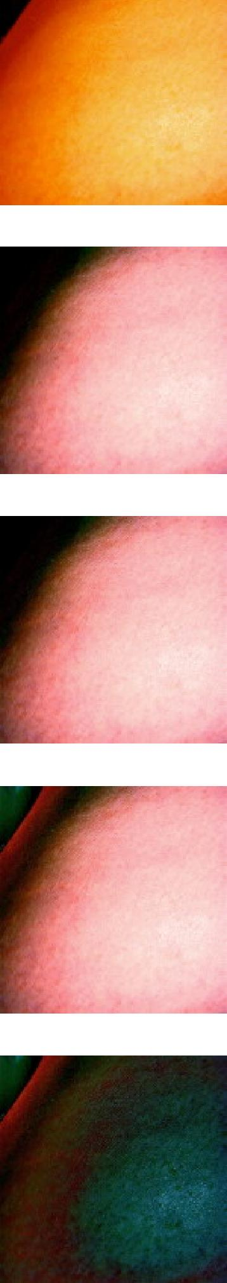

http://www.printfriendly.com/print/?source=homepage&url=http%3A%2F%2Fgrovecanada.ca%2Fdiy-mammogram%2F Page 2 of 4

PrintFriendly.com: Print web pages, create PDFs | 15-03-10 10:31 AM

http://www.printfriendly.com/print/?source=homepage&url=http%3A%2F%2Fgrovecanada.ca%2Fdiy-mammogram%2F Page 3 of 4

PrintFriendly.com: Print web pages, create PDFs | 15-03-10 10:31 AM

http://www.printfriendly.com/print/?source=homepage&url=http%3A%2F%2Fgrovecanada.ca%2Fdiy-mammogram%2F Page 4 of 4

